Marketing challenges can be described as issues marketers must resolve in order to achieve the organization’s mission.

It is good practice to define a new business’s initial set of marketing challenges right from the start. Marketers review and update their marketing challenges on an on-going basis.

New challenges are identified as required and the progress of solutions to existing challenges is constantly monitored.

A marketing challenge should be worded in one simple sentence. If you cannot do this, you do not understand the challenge sufficiently to be able to overcome or achieve it.

There are three parts to a marketing challenge:

- What you are going to do
- Quantification --- or how much of it
- Term --- the time period during which you will achieve it

It is important to incorporate all three parts into every marketing challenge.

An example of a marketing challenge for a new vitamin distributor selling to retail stores might be:

“We will have our vitamins available for sale in 100 retail stores in Manhattan within the first 12 months of doing business.”

- What you are going to do: “We will have our vitamins available for sale in retail stores in Manhattan.”
- Quantification: “100 retail stores”
- Term: “within the first 12 months of doing business.”

Marketers develop strategies to resolve marketing challenges. A separate strategy will be developed and implemented to resolve each marketing challenge. Often more than one strategy will be developed and implemented to resolve a marketing challenge.

Reference 4: page 55: Create Company Goals and Objectives

Before entrepreneurs can build a comprehensive set of strategies, they must first establish business goals and objectives, which give them target to aim for and provide a basis for about a waiting their company's performance. Without these goals and objectives, entrepreneurs cannot know where the business is going or how well is performing. Creating goals and objectives is an essential part of the strategic management process.

Goals. Goals are the broad, long-range targets the business seeks to accomplish; they tend to be general and sometimes even abstract. Goals are not intended to be specific enough for a manager to act on but simply state the general level of accomplishment saw. Do you want to boost your market share? Does your cash balance need strengthening? Would you like to enter a new market or increase sales in a current one? What return on your investment do you seek? Researchers Jim Collins and Perry Porras studied a large group of businesses and determined that one of the factors that set apart successful companies from unsuccessful ones was the formulation of very ambitious, clear, and inspiring long-term goals. Collins and Porras called them BHAGs (“Big Hairy Audacious Goals," pronounced "bee-hags") and say that their main benefit is to inspire and focus the company on important actions that are consistent with its overall mission.

Addressing these brought issues will help you focus on the next phase --- developing specific, realistic objectives.

Objectives. Objectives are more specific targets of performance. Common objectives address profitability, productivity, growth, efficiency, markets, financial resources, physical facilities, organizational structure, employee welfare, and social responsibility. Jim Collins suggests that the objectives a company sets determine the level of success it achieves. Establishing profitability targets is not enough. Instead, entrepreneurs must set objectives and measure performance in those critical areas that determine they are Company's ability to be profitable -- a concept he calls a company's true economic denominators. Those denominators might be the cost of acquiring a customer, sales per labor hour, the customer retention rate, the rate of inventory turnover, or some other factor. Dell Computer, for instance, has left most of its competitors in the dust by focusing on one of its true economic denominators, achieving a phenomenal inventory turnover ratio of 73 times a year! Unfortunately, Collins claims fewer than 10% of all companies understand what their true economic denominators are. Because objectives in one area of the company might conflict with those in another area of the company, entrepreneurs must establish priorities. Which objectives are most important? Arranging objectives in a hierarchy according to their priority can help business owners resolve conflicts when they arise.

Well written and objectives have the following characteristics:

They are specific. Objectives should be quantifiable and precise. For example, "to achieve a healthy growth in sales" is not a meaningful objective, but "to increase retail sales by 12% and wholesale by 10% in the next fiscal year" is precise and spells out exactly what management wants to accomplish.

They are measurable. Managers should be able to plot the organization's progress towards its object is, this requires a well-defined reference point from which to start and a scale for measuring progress.

They are assignable. Unless an entrepreneur assigns responsibility for an objective to an individual, it is unlikely that the company will ever achieve it. When you creating objectives without giving someone responsibility for accomplishing them is futile.

They are realistic, yet challenging. Objectives must be within the reach of the organization or motivation will disappear. In any case, managerial expectations must remain high. In other words, the more challenging and objective is (within realistic limits), the higher the performance will be. Set objectives that will challenge your business and its employees.

They are timely. Objectives must specify not only what is to be accomplished but also when it is to be accomplished. A timeframe for achievement is important.

They are written down. This writing process does not have to be complex; in fact, the manager should make the number of objectives relatively small, from five to fifteen.

The strategic planning process works best when managers and employees are actively involved jointly in setting objectives. Developing a plan is top management's responsibility, but executing it falls to managers and employees; therefore, encouraging them to participate broadens the plan's perspective and increases the motivation to make the plan work. In addition, managers and employees know a great deal about the organization and usually are willing to share this knowledge.

Reference 2: page 10: DETERMINE OBJECTIVES AND DIRECTION

Marketing pathfinders are responsible for setting the direction of the organization's marketing activities based on goals and objectives. Goals are longer-term performance targets, whereas objectives are shorter-term targets that support the achievement of goals. Before charting any path, therefore, marketers must review the organization's overall mission and goals, then set marketing objectives that will steer the organization closer to its ultimate destination. The marketing and financial objectives that are set (and eventually achieved) will give the organization more momentum on the journey toward its overall goals, whatever they may be and however they may be expressed (in terms of sales, profits, market share, or other measures).

Starting in the 1970s, for example, executives at Target Stores established a mission strategy to guide the company's growth. Although the mission has been revised periodically, basic tenets that have not changed for 30 years include the idea that target is a "trend merchant" and sells "higher-quality merchandise." This mission provides ongoing direct shin for the retailer's top management to set specific long-term growth goals and short-term marketing and financial objectives to be achieved through the development and implementation of a detailed marketing plan.

Reference 13: page 37: Functional Goals and Objectives

Marketing and all other business functions must support the organization's mission and goals, translating these into objectives with specific quantitative measurements. For example, a corporate or business unit goal to increase return on investment might translate into a marketing objective to increase sales, a production objective to reduce the cost of raw materials, a financial objectives to rebalance the firm's portfolio of investments, or human resources objective to increase employee training and productivity. All functional objectives should be expressed in clear, simple terms so that all personnel understand what type and level of performance that the organization desires. In other words, objectives should be written so that their accomplishment can be measured accurately. In the case of marketing objectives, units of measure might include sales volume (in dollars or units), profitability per unit, percentage gain in in market share, sales per square foot, average customer purchase, percentage of customers in the firm's target market who preferred its products, or some other measurable achievement.

It is also important for all functional objectives to be reconsidered for each planning period. Perhaps no strategy arose in the previous planning period to meet the stated objectives. Or perhaps the implementation of new technology allowed the firm to greatly exceeded subjectivist. In either case, realism demand is the revision of functional objectives to remain consistent with the next edition of the functional area plan.

Page 43: Marketing Goals and Objectives Marketing goals and objectives are formal statements of the desired and expected outcomes resulting from the marketing plan. Marketing goals are broad, simple statements of what will be accomplished through the marketing strategy. The major function of goals is to guide the development of objectives and to provide direction for resource allocation decisions. Our more specific and are essential to planning. Objectives should be stated in quantitative terms to permit reasonably precise measurement. The quantitative nature of marketing objectives makes them easier to implement after development of the strategy.

This section of the marketing plan has two important purposes. First, it sets the performance targets that the firm seeks to achieve by giving life to its strategic focus through its marketing strategy (that is, what the firm hopes to achieve). Second, it defines the parameters by which the firm will measure actual performance in the evaluation and control phase of the marketing plan (that is, how performance will actually be measured). At this point, it is important to remember that neither goals nor objectives can be developed without a clearly defined mission statement. Marketing goals must be consistent with the firm's mission, and marketing objectives must flow naturally from the marketing goals.

Page 139: Developing Marketing Goals

As statements abroad, desired accomplishments, goals are expressed in general terms and do not contain specific information about where the organization presently stands or where it hopes to be in the future. Electronics retailer Circuit City, for example, has a goal of having lower prices than the competition. This goal is not specific, however, because it does not specify a benchmark that defines what a lower price is. To achieve these goals, Circuit City offers a price guarantee that match is then beats competitors prices by 10%. Goals like these are important because they indicate the direction in which the firm attempts to move, as well as the set of priorities it will use in evaluating alternatives and making decisions.

It is also important that all functional areas of the organization be considered in the goal-setting process. In developing goals for the marketing plan, it is important to keep in mind that marketing goals should be attainable, consistent, comprehensive, and involves some degree of intangibility. Failure to consider these issues will result in goals that are less effective and perhaps even dysfunctional. Let's look more closely at these characteristics.

Attainability Setting realistic goals is important because the key parties involved in reaching them must see each goal as reasonable. Determining whether a goal is realistic requires an assessment of both the internal and external environments. For example, it would not be unrealistic for a firm in second place in market share, trailing the leading brand by just 2%, to set a goal of becoming the industry leader. Other things being equal, such a goal could help motivate employees toward becoming the "number one." In contrast, a firm in sixth place, trailing the fifth place for my 5% and the leader by 30%, could set the same goal -- but it would not be realistic. Unrealistic goals can be demotivational because they show employees that management is out of touch. Because one of the primary benefits of having goals is to motivate employees toward better performance, setting unrealistic goals can cause major problems.

Consistency In addition to being realistic, management must work to set goals that are consistent with one another. Enhancing market share and working to have the highest profit margins in the industry are both reasonable goals by themselves, but together they are inconsistent. Goals to increase both sales and market share would be consistent, as would goals to enhance customer service and customer satisfaction. However, setting goals to reduce inventory levels and increase customer service are usually incompatible. Goals across and within functional areas should also mesh together. This is a major concern in larger organizations and it highlights the need for a great deal of information sharing during the goal formulation process.

Comprehensiveness The goal setting process should also be comprehensive. This means that each functional area should be able to develop its own goals that relate to the organization's goals. For example, if goals are set only in terms of advancing the technology associated with the firm's products, members of the marketing department may wonder what role they will play in his accomplishment. The goal should be stated so that both marketing and research and development can work together to help advance the organizational goal of offering the most technologically advanced products. Marketing will need to work on the demand side of this effort (measuring customer needs and staying attuned to trends in the external environment), while research and development will focus on the supply side (conducting basic and applied research, as well as staying abreast of all major technological innovations). Goals should help clarify the roles of all parties in the organization. Functional areas that do not match any of the organization's goals should question their need for future resources and their ability to acquire them.

Intangibility Finally, goals should involve some degree of intangibility. Some planners have been known to confuse strategies, and even tactics, with goals. A goal is not some action that the firm can take; rather it is an outcome that the organization hopes to accomplish. Actions such as hiring 100 new salespeople or doubling the advertising budget are not goals because any firm with adequate resources can accomplish both tasks. However, having "the best trained sales force in the industry" or "the most creative and effective advertising campaign in the industry" are suitable goals. Note the intangibility associated with the use of terms such as best trained, most creative, and most effective. These terms are motivational because they promote comparisons with rival firms. They also continually push for excellence because their open-ended nature always leaves room for improvement.

Developing and Marketing Objectives

Objectives provide specific and quantitative benchmarks that can be used to gauge progress toward the achievement of the marketing goals. In some cases, a particular goal may require several objectives for its progress to be adequately monitored you do, usually across multiple business functions. For example, a goal of "creating a high quality image for the firm" cannot be accomplished by better inventory control if Accounts Receivable makes mistakes and customer complaints about the firm's sales people are on the rise. Similarly, the marketing department alone could not have accomplished The Home Depot is phenomenal growth in stores -- up 20% in the past two years. Such an endeavor requires a carefully coordinated effort across many departments.

Goals without objectives are essentially meaningless because progress is impossible to measure. A typical marketing objective might be that "the sales division will decrease unfilled customer orders from 3% to 2% between January and June of this fiscal year." Note that this objective contains a high degree of specificity . It is this specificity that sets goals and objectives apart. Objectives involve measurable quantitative outcomes, with specifically assigned responsibility for their accomplishment and a definite time period for their attainment. Let's look at the specific characteristics of marketing objectives.

Attainability As with goals, marketing objectives should be realistic even the internal and external environments identified during the situation and SWOT analyses. A good objective is one that is attainable with a reasonable amount of effort. Easily attainable objectives will not motivate employees to achieve higher levels of performance. Likewise, good objectives do not come from false assumptions that everything will go as planned or that every employee will give 110% effort. In some cases, competitors will establish objectives that include taking customers and sales away from the firm. Setting objectives that assume in animate or inept competitors, when history is proven otherwise, creates objectives that quickly lose their value as employees recognize them as being unreasonable.

Continuity The need for realism brings up a second consideration, that of continuity. Marketing objectives can be either continuous or discontinuous. A firm uses continuous objectives when its current objectives are similar to objectives set in the previous planning period. For example, an objective "to increase market share from 20 to 22% in the next fiscal year" could be carried forward in a similar fashion to the next.: "to increase market share from 22 to 24% in the next fiscal year." This would be a continuous objective because the factor in question and the magnitude of change are similar, or even identical, for period to period.

An important caveat about continuous objectives: objectives that are not identical or even slightly modified from period to period often do not need new strategies, increased effort or better implementation to be achieved. Marketing objectives should lead employees to perform at higher levels than with other allies have been the case. Employees naturally tend to be objective oriented. Once they meet the objective, the level of creativity and effort tends to fall off. There are certainly circumstances where continuous activities are appropriate, but they should not be set simply as a matter of habit.

Discontinuous objectives significantly evaluate the level of performance on a given outcome factor or bring new factors into this set of objectives. If sales growth has been averaging 10% and the SWOT analysis suggests that this is an easily obtainable level, an example of the discontinuous objective might be "to increase sales 18% during the next fiscal year." This would require new strategies to sell additional products to existing customers, to expand the customer base, or at the very least to develop new tactics and/or enhance the implementation of existing strategies. Discontinuous objectives require more analysis and linkage to strategic planning and continuous objectives.

Time Frame Another key consideration in setting objectives is the time frame for their achievement. Although companies often establish marketing plans on an annual basis, marketing objectives may differ from this period in their time frame for their achievement. Although companies often establish marketing plans on an annual basis, marketing objectives may differ from this period in their time frame. Sales volume, market share, customer service, and gross margin objectives may be set for terms less than, equal to, or greater than one year. If the timeframe should be appropriate and allow for accomplishment with reasonable levels of effort. To set a target of doubling sales were a well-established company within six months would likely be unreasonable. On the other hand, objectives having an excessively long time frame may be attained without any increased effort or creativity. The combination of managerial expertise and experience, along with the information acquired during the situation and SWOT analyses, should lead to the establishment of an appropriate timeframe.

For objectives with longer time frames, it is important to remind employees of the objective on a regular basis and to provide feedback on progress toward his achievement. For example, employees at Federal Express’s terminal in Memphis, Tennessee, can see a real-time accuracy gauge that displays the company's current performance in terms of getting packages to their rightful destinations. FedEx also uses a nightly countdown clock to remind employees of the speed needed to turn around packages and load them on outbound cargo planes. Whether a weekly announcement, all monthly newsletter, or a real-time gauge on the wall that charts progress toward the objective, feedback is a critical part of the objective setting process, particularly for longer-term objectives.

Assignment of Responsibility One final aspect of objectives that sets them apart from goals is that the marketing manager must identify the person, team, or unit responsible for achieving each objective. By explicitly assigning responsibility, the firm can limit the problems of stealing credit and avoiding responsibility. A bank might give the marketing department the responsibility of achieving objective of "having 40% of its customers lists the bank as their primary financial institution within one year." If by the end of the year, 42% of all customers list the bank is their primary financial institution, the marketing department gets credit for this outcome. If the figure is only 38%, the marketing department must provide an explanation.

Moving Beyond Goals and Objectives

Marketing goals and objectives identified the desired ends, both general and specific, but the organization hopes to achieve during the planning period. However, companies do not fulfill properly set goals and objectives automatically or through wishing and hoping. They set into motion a chain of decisions and serve as a catalyst for the subsequent stages in the planning process. Organizational goals and objectives must lead to the establishment of consistent goals and objectives for each functional area of the firm. Having recognized the desired ends, each area, including marketing, must next determined means that will lead to these targeted results.

Reference 14: page 69: Differences in Goals and Objectives

Another important difference across generic business level strategies with particular relevance for the design and implementation of appropriate marketing programs is that different strategies often focus on different objectives. Strategic Business Unit (SBU) and product market objectives might be specified on a variety of criteria, but to keep things simple, we focus on only three performance dimensions of major importance to both business unit and marketing managers:

- Effectiveness. The success of a business' s products and programs relative to those of its competitors in the market. Effectiveness is commonly measured by such items as sales growth relative to competitors or changes in market share.
- Efficiency. The outcomes of a business’s programs relative to the resources used in implementing them. Common measures of efficiency are profitability as a percent of sales and return on investment.
- Adaptability. The business’s success in responding over time to changing conditions and opportunities in the environment. Adaptability can be measured in a variety of ways, but the most common ones are then number of successful new products introduced relative to those introduced by competitors or the percentage of sales accounted for by products introduced within the last five years.
However, it is very difficult for any SBU, regardless of its competitive strategy, to simultaneously achieve outstanding performance on even this limited number of dimensions, because they involve substantial trade-offs. Good performance on one dimension often means sacrificing performance on another. For example, developing successful new products or attaining share growth often involves large marketing budgets, substantial upfront investment, high operating costs, and the shaving of profit margins -- all of which reduce ROI. This suggests that managers should choose a competitive strategy with a view toward maximizing performance on one or two dimensions, while expecting to sacrifice some level of performance on the others, at least in the short term. Over the longer term, of course, the chosen strategy should promise discounted cash flows that exceed the business’s cost of capital and thereby increase shareholder value.

As Exhibit 3.1 indicates, you prospector businesses are expected to outperform defenders on both new product development and market share growth. On the other hand, both defenders strategy should lead to better returns on investment. Differentiated defenders likely produce higher returns than low-cost defenders, assuming that the greater expenses involved in maintaining their differentiated positions can be more than offset by the higher margins and gained by avoiding the intense price competition and low-cost competitors often face. Once again, both low-cost and differentiated analyzer strategies are likely to fall between the two extremes.

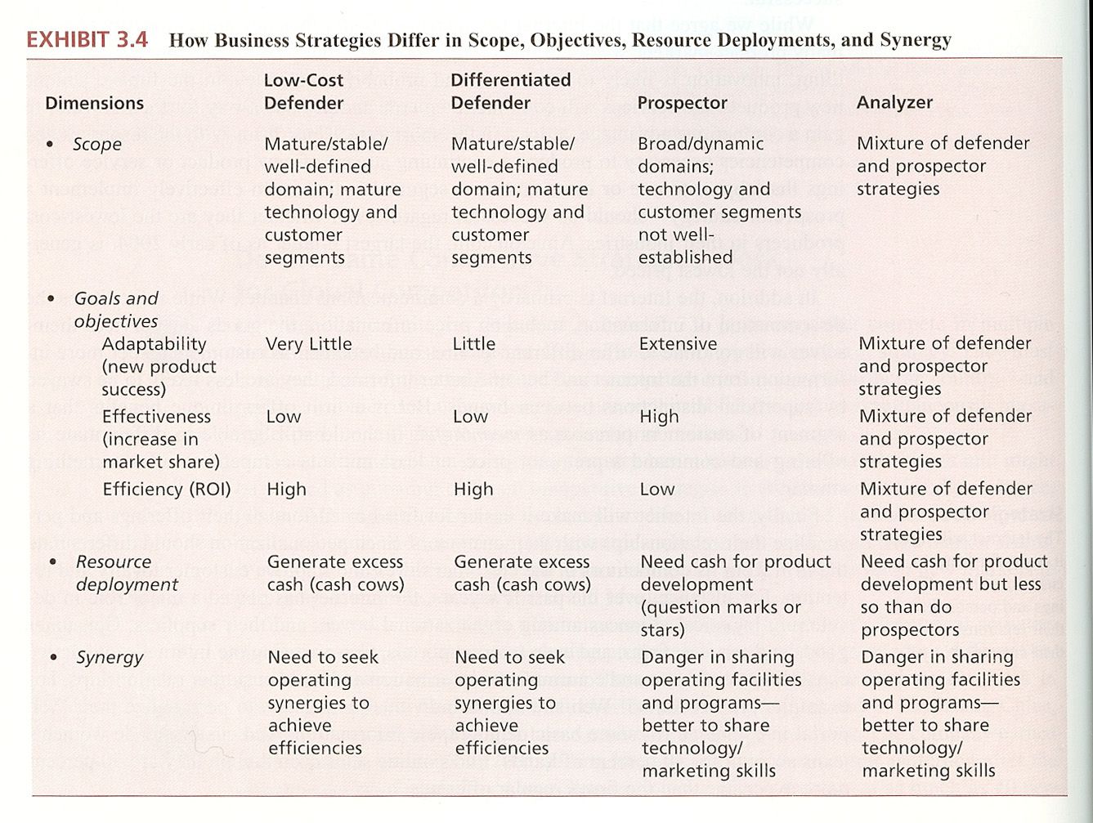

Reference 24: page 154: Setting Goals and Objectives

We use goals to refer to the longer term, strategic directions that the firm pursues, which often are imprecisely stated or qualitative. In contrast, we use objectives to refer to the near term, more measurable standards that a firm uses to judge whether it achieved what it wanted to accomplish during a specific time period. In this way, objectives serve as milestones that enable the firm to charts progress in attaining its goals. A firm pursues its strategic intent in this way, by broadly specifying the path to achieving it, and then establishing intermediate milestones and review mechanisms to track progress.

The business must specify measures that correspond to its objectives (and goals) or that signal the extent to which the firm is accomplished the market and financial performance envisioned. Examples of informative measures of market performance including increased share of customers total requirements by market segment (supplier share of customers business), number of new customers by market segment, and sales of new products by market segment. Examples of informative measures of financial performance include segment contribution, customer contribution to profitability, and incremental revenues from optional, value adding services.

Progressive firms should look at cash flow is a measure that bridges market performance and financial performance. Marketplace initiatives can accelerate and enhance cash flows, reduce their volatility and vulnerability, and enhance their long-term residual value. Cash flow is a critical measure of financial performance for a firm, as financial markets often use the net present value of cash flows as an indicator of shareholder value. Related to this, senior management at Siemens, for example, is compensated largely on the basis of accomplishing Economic Value Added (EVA) objectives, which reflect the extent to which net operating profit after tax exceed the cost of capital employed.

Successive layers of management translate the business is marketing goals and objectives into group and individual goals and objectives. Some firms use the balanced scorecard, which assesses customer, financial, internal business process, and learning and growth performance, as a mechanism to accomplish this. Researchers found that one of the best ways to gain superior cross functional cooperation is to have some objectives, and rewards for accomplishing them, at the broader level of the cross functional unit. Even within the marketing and sales functional area, shared objectives and rewards significantly improve coordination. Also, senior management must prioritize and consider linkage implications among the objectives that the firm sets. For example, gaining new customers at lowering the cost of sales as a percentage of total cells must often have a negative linkage because getting new customers typically requires a number of sales calls before the first sale.

Often, the significant slippage or disconnect to occur between stated objectives and the measures that the firm uses for performance review and reward. Predictably, individuals in the workforce seek to excel on these measures, with business performance on the objectives falling short. The situation was captured in the title of a classic management article, "On the Folly of Rewarding A, While Hoping for B." and often occurring example in business markets is the folly of rewarding salespeople on revenue or volume, while hoping for profitability. Even in instances where some measure of offering or customer profitability is a part of the salesperson review and reward system, it's wading relative to revenue or volume measures of that is insufficient to focus sales person actions on profitability over volume or revenue. To remedy this problem, tighter linkages are needed between what senior management wants to happen and the measures that they put in place to evaluate the performance of the individuals who are responsible for accomplishing those objectives.

Finally, the firm should set goals and objectives for learning about the marketplace. For example, a goal for might want to accomplish is to become and remain the industry leader in knowledge about customer requirements and preferences, and how they are changing. Setting learning goals and objectives should trigger the commitment of resources and specification of mechanisms for learning. A firm might increase the number of customer value assessments and market experiments that it conducts. Having goals and objectives for market learning also causes the firm to rethink the meaning of, and how it regards, failure. Even though initiatives fall short of their financial or market objectives, they might be strong contributors to the firm's learning and subsequent market success. Each time the firm engages in planning, it wants to be better equipped to answer the question, "what do we know?" Then it was previously.

Page 224: Development Goals and Objectives

In defining its development goals and objectives, big business specifies what is seeking to achieve in new offering realization. Obviously, it wants greater success, but defining what exactly "greater success" means is crucial. In doing so, management confronts conflicts that exist among the goals and objectives, and through debate and discussion, makes the required trade-offs. Further, management needs to distinguish between goals for new offering realization as a whole and objectives for individual development projects.

Overall Development Goals
Because of different business strategies that they are pursuing, it him firms may vary in the overall goals they set for new offering realization. The overall goals of learning, efficiency, and speed-to-market should be of interest to management regardless of the business strategy to firm is pursuing, although the relative emphasis placed on each may vary depending on the business strategy. Learning refers to gains in design and process knowledge and know-how, and is paramount or organizational enhancement and renewal to occur. To gain the most, a firm needs to manage learning across all realization efforts. Chaparral Steel, a steel minimill located in Texas, does three things that maximize its overall learning from its development efforts:

First, it requires every development project to advance the company's capabilities. Second, it carefully plans which series of projects to undertake and how to carry them out so that all together they will strengthen the company's overall set of capabilities. And third, after each project has been completed, chaparral analyzes it to find out what it achieved or failed to achieve so the organizational lessons -- not flowcharts and organizational structures but the way people actually work best together --- can be passed on to subsequent projects.

Efficiency concerns getting the most out of available resources. As with learning, to gain the most, a firm needs to manage efficiency across all realization efforts. For example, one measure that you look back at uses to monitor its overall realization efficiency is "' Project team changeover waste': the cost of time and resources spent between the end of the previous effort and the point at which all team members are again fully engaged in value adding act Trinity.

Speed-to-market refers to the time it takes to complete the development cycle and improving it has become almost a mantra for a new offering realization in business markets. Yet, the firm must understand what advantage speed-to-market provides and how it gages performance for this goal. As an example, the semiconductor company analog devices uses the concept of half-life to gauge its performance on speed-to-market: the time to complete a realization project should decrease by half for each constant period of time, such as every two years. So, the time to market should decrease from 36 months to 18 months to nine months over successive two-year periods. Analog devices will need to revise how they gauge performance on his goal at some point, though, because becoming faster no longer will provide an advantage, suggesting that other goals will become predominant. Von Braun has cautioned firms about the harmful consequences of an acceleration trap, where a technology driven firms introduce and discontinue products faster and faster.

Managing speed-to-market at the overall level can dramatically affect the speed-to-market of individual projects. Demands for the same resources from multiple projects, such as support technician to perform testing of prototypes, and create bottlenecks that cause lengthy project delays. Adler, Mandelbaum, Nguyen and Schwerer and firms lowered their planned usage of development resources from 90% to 80% of overall capacity, they could decrease development cycle times by 30% or more. So building in Slack can reduce overall development times.

Defining the overall goals of new offering realization (and the measures that will assess their achievement) Reza conflicts that exist among these goals into sharper focus for management. The previous example illustrates a trade-off between efficiency and speed-to-market as overall new offering realization objectives. Similarly, learning as a goal will adversely affect speed-to-market and efficiency in that establishing learning goals and conducting learning audits takes time and other resources. The trade-off in favor of having learning as an overall goal is based upon the belief that it will actually pay sick addictive dividends in increasing the speed-to-market and efficiency of realization efforts as a whole. Management needs to validate such beliefs over time with internally generated data, just as it needs to validate market views with market data.

Finally, as an overall assessment of new offering realization performance, some firms use the sales or profits that new offerings generate. Medtronic, a leading medical device company, has as its stated policy that 70% of revenue should come from products launched within the past two years. DuPont Co. recently promised that by 2005, 1 third of its revenues will come from products introduced in the last five years, which would represent substantial improvement.

Project Objectives

Individual development projects play different roles and affirms realization efforts, as we discussed in the next section on aggregate project plans. Thus, the relative emphasis management places on specific objectives will vary across projects. Smith and Reinertsen, product development consultants, contend that firms must balance for key objectives and managing individual development projects:

- Development speed or time-to-market, which is "the time between the first instance someone will could have started working on a development program and the instant the final product was available to the customer"
- Product cost, which is the total cost of the product to the supplier, including all costs it incurs in marketing, sales, and support services (better part of the purchase price customers pay)
- Product performance, which is how well the product meets the requirements and preferences that target customers have specified
- Development program expense , which consists of all the one time development costs a specific project incurs

Smith and Reinertsen observed that every development project will have to confront trade-offs among these four objectives, and making them correctly is paramount for project success. For example, outsourcing some part of a project adds to the development program expense, but it lowers the time-to-market. The guide managers in making these trade-off decisions, Smith and Reinertsen recommend comparing different cases using cumulative profits over the life of the product as the criterion measure. They advise managers to construct an economic model using spreadsheet software to explore the effects of trade-offs on cumulative profits. This kind of analysis can produce insights, managers must be cautious about relying too much on the apparent certainty of quantification. The accuracy of the data used and the assumptions made in constructing the relationships among the variables are crucial in determining the models practical work. For example, although cumulative profits may be a worthwhile indicator of financial success, as we have seen, managers may want to consider other realization goals, such as learning, as well. Taking them into account will lead managers to make more complicated, qualitative judgments on trade-off decisions.

To understand the varying roles or contacts of individual projects, doling advocates that the firm used a nudist map that has two dimensions: the newness of the developed product or service to the firm (low to high), and the newness to the market (low to high). A firm can portray as portfolio of projects on this map to recognize what the Paramount marketing issues will be for each project. As an example, when the anticipated outcome of a project is an offering that will be low to moderate a nudist to the firm and newness to the market, cannibalization versus incremental sales is a Paramount marketing issue. Cannibalization is when a new offering takes a portion of its sales from an existing offering of the firm. The firm may be willing to end the war some cannibalization when its objective for the new offering is to blunt inroads made by a recently introduced competitors offering. Alternatively, its objective may be to maximize cannibalization, as, for example, when the new offering as greater profitability than the existing offering. Plus, management sets the objectives for projects based on its understanding of their context.

What measures to firms use to assess the achievement of project objectives? To capture variation in project roles, Griffin and page constructed six development scenarios that systematically vary along the two dimensions of the newness map. Experienced practitioners judged which measures were most useful for evaluating the success of individual products for each of these six scenarios. The set of measures that the practitioners of evaluating comprised customer base, financial, and technical performance measures of success. With new to the world projects (high newness to the firm and to the market), practitioners regard marketplace reaction measures such as customer acceptance and customer satisfaction as most useful. For line extensions (moderate newness to the firm and to the market), meeting profit goals, competitive advantage, and market share of the most useful measures.

Best practice firms do not simply rely on post-project measures to about a weight project performance. They also devise measures that can be used during a project to provide an early warning signals and suggest corrective actions. Recognizing and responding to development problems as they occur increases the rate of project success. "Therefore, smart innovators and leading in process indicators that measure, for example, anticipated breakeven time, quality of planning, conformance to best practices, time spent with customers, timeliness of deliverables, thoroughness of early engineering analysis, and quantity of resources."
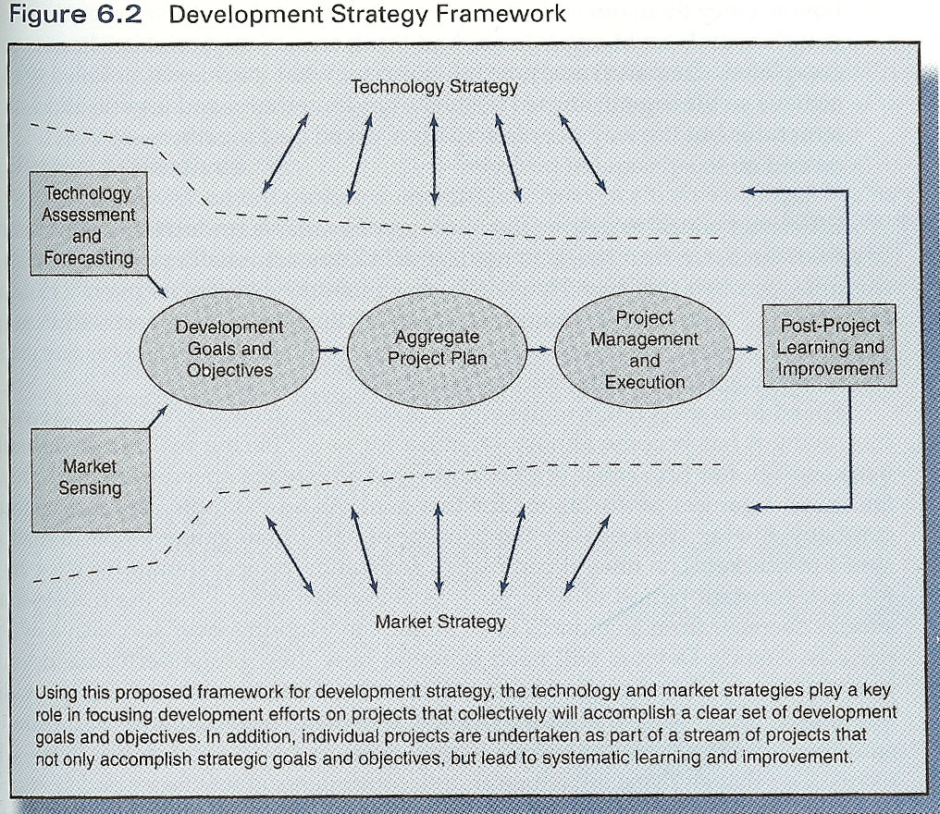

Reference 15: page 86: Performance Objectives

Once the mission statement has been determined, the next step is to establish the goals and objectives that the strategic plan is expected to accomplish. Performance objectives generally are stated in measurable terms, such as return on investment or other profitability or productivity measures that are to be accomplished within a specified period of time. Strategic objectives can be determined for separate divisions, departments, or other organizational units. Objectives established for one level or business unit should support and be compatible with those of other levels or units of the business.

Page 92: Strategic Objectives and Strategy Definition

Once management has a clear understanding of its external and internal environments, the next step is to establish realistic objectives to be achieved by the strategic plan. These are generally stated in terms of marketing objectives and financial objectives. Financial objectives generally are stated in terms of profitability, performance, or productivity (e.g., 18% return on investment). Marketing objectives generally are stated in such terms as sales, market share, customer satisfaction, or communications objectives (e.g., 25% market share, 30% increase in brand awareness). After the strategic objectives are established, the overall strategy that will be used to accomplish these objectives must be defined. This is a broad statement for the longer term and is used to drive the details of the specific short and long-range plans.

Reference 6: page 8:

In an article listing reasons why businesses fail, Douglas Gray, a Vancouver Canada-based speaker, lawyer, columnist and author of 15 business books included the following, "Failure to set and revise goals. Many people do not determine their goals or objectives, or, if these targets are set, they are ineffective because they are not measurable, specific, or realistic. Failure to reassess goals can create serious problems. Barry is direct and indirect factors can affect your goals and require them to be modified in order to remain viable and effective. For example, unexpected problems could occur, such as illness of the owner, new competition, overly ambitious timetables, supplier delays, an increase in lending rates, or loss of a major client."

Reference 7: page 105: Step 6. Create Company Goals And Objectives

Before entrepreneurs can build a comprehensive set of strategies, they must first establish business goals and objectives, which given the target to aim for and provide a basis for evaluating their company's performance. Without them, it is impossible to know where a business is going or how well it is performing. The following conversation between Alice and the Cheshire cat, taken from Lewis Carroll's Alice in Wonderland, illustrates the importance of creating meaningful goals and objectives as part of the strategic management process:

"Would you please tell me, which way I ought to go from here?" asked Alice.

"That depends a good deal on where you want to get to," said the Cat.

"I don't much care where...," said Alice.

"Then it doesn't matter which way you go," said the Cat.

A small business that "doesn't much care where" it wants to go (i.e., one that has no goals and objectives) will find that "it really doesn't matter which way" it chooses to go (i.e., its strategy is irrelevant).

Reference 10: page 6: MARKETING GOALS AND OBJECTIVES

Marketing goals and objectives are accomplishments you intend to achieve with the help of your marketing plan. You have already prepared your reader by your earlier analysis of the target market. In this section you must spell out in detail exactly what you intend to do.

What is the difference between a goal and objective? And objective is an overall goal. It is more general and may not be quantified. "To establish a product in the marketplace" is an objective. So is "to become a market leader" or "to dominate the market." In goals are quantified. "To sell 10,000 units a year" is a goal. Goals are also quantified in terms of sales, profits, market share, return on investment, or other measurements. There is one major cautionary note here: don't get trapped into setting objectives or goals that conflict. For example, your ability to capture a stated market share may require lower profits. Make sure that all your goals and objectives stick together. You can do this by adjusting and reconfirming your goals and objectives after you have completed the financial portions of your plan.

Reference 16: page 18: Formulating Strategic Marketing Programs

Designing an effective strategic marketing program for a product market entry involves three interrelated sets of decisions:

- The manager must set specific objectives to be accomplished within the target market, such as sales, volume, market share, and profitability goals. Those objectives must be consistent with the firm's corporate and business unit strategic objectives, yet specific enough to enable management to monitor and evaluate the product market entries performance over time.
- The manager must decide on an overall marketing strategy to appeal to customers -- and to gain a competitive advantage --- in the target market. The strategy must be consistent with the firm's capabilities, its corporate and business unit strategies, and the product market objectives.
- The manager must then make decisions about each element of the tactical marketing program used to carry out a strategy. These decisions must be internally consistent and integrated across all elements of the marketing program.

Specifying Marketing Objectives and Strategies

The first step in developing a strategic marketing program is to specify the objectives and the overall marketing strategy of each target market. As we've mentioned, these are partly picked hated by corporate and business level objectives, strategies, and resources. For instance, the nature of Samsung's product line, its pricing and distribution policies, and its advertising appeals and promotion efforts are all influenced by the firm's competitive strategy of offering technical innovative and stylish electronics products at premium prices.

Page 47: Corporate Objectives

Confucius said, "for one who has no objective, nothing is relevant." Formal objectives provide decision criteria that guy and organization's business units and employees toward specific dimensions and performance levels. Those same objectives provide benchmarks against which actual performance can be evaluated.

To be useful as decision criteria and evaluative benchmarks, corporate objectives must be specific and measurable. Therefore each objective contains four components:

- A performance dimension or attribute sought.
- A measure or index for evaluating progress.
- A target or hurdle level to be achieved.
- The time frame within which the target is to be accomplished.

Exhibit 2.8 is some common performance dimensions and measures used in specifying corporate as well as business unit and marketing objectives.

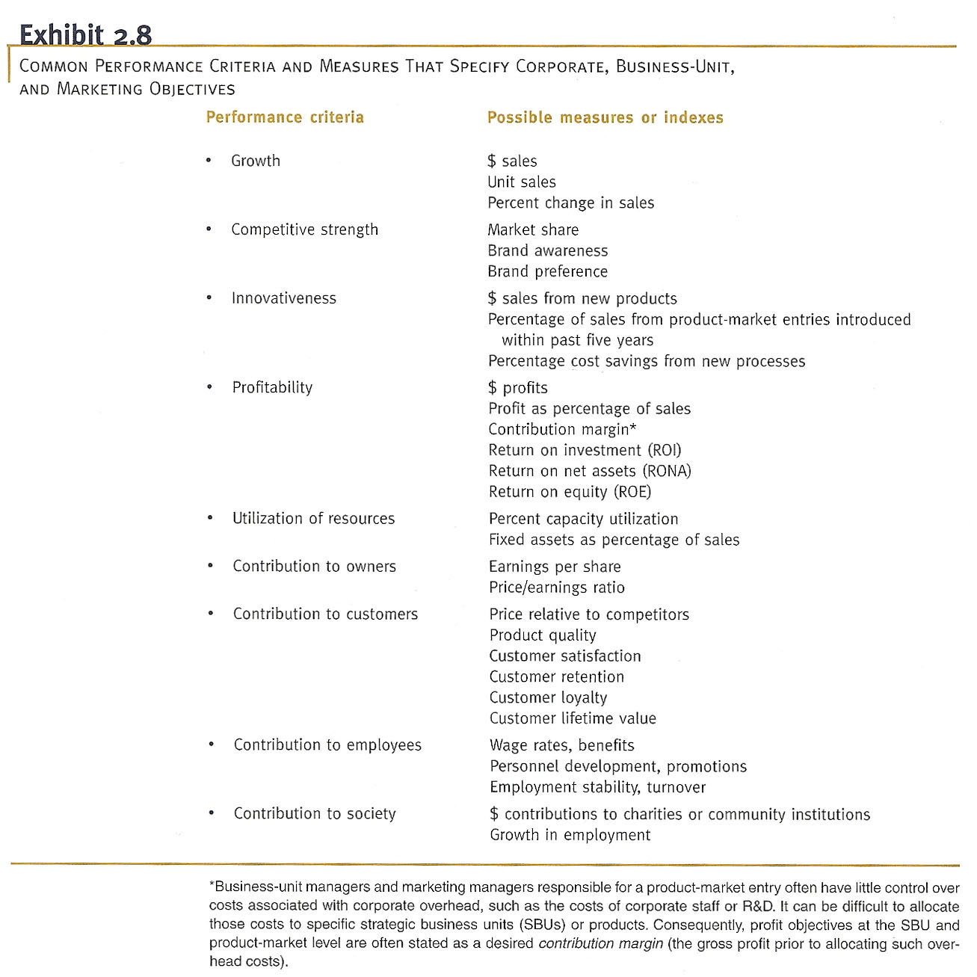

The Marketing Implications of Corporate Objectives

Most organizations pursuing multiple objectives. This is clearly demonstrated by a study of the stated objectives of 82 large corporations. Largest percentage of respondents (89%) had explicit profitability objectives; 82% reported growth objectives; 66% had specific marketshare goals. More than 60% mention social responsibility, employee welfare, and customer service objectives, and 54% of the companies had RND/new product development goals. These percentages add up to more than 100% because most firms had several objectives.

Trying to achieve many objectives at once leads to conflict and trade-offs. For example, the investment and expenditure necessary to pursue growth in the long term is likely to replace profitability and ROI in the short term. Managers can reconcile conflicting goals by prioritizing them. Another approach is to state one of the conflicting goals as a constraint or hurdle. Thus, a firm attempts to maximize growth subject to meeting some minimum ROI hurdle.

In firms with multiple business units or product lines, however, the most common way to pursue a set of conflicting objectives is the first break them down into some objectives, then assign sub objectives to different business units or products. Thus, some objectives often vary across business units and product offerings depending on the attractiveness and potential of their industries, the strength of their competitive positions, and the resource allocation decisions made by corporate managers. For example, PepsiCo's managers likely set relatively high volume and share growth objectives but lower ROI goals for the firm's aqua Pinot brand, which is battling for prominence in the rapidly growing bottled water category, then for ladies potato chips, which hold a commanding 40% share of a mature product category . Therefore, two marketing managers responsible for different products may face very different goals and expectations --- requiring different marketing strategies to accomplish --- even though they work for the same organization.

As firms emphasize developing and maintaining long-term customer relationships, customer-focused objectives --- such as satisfaction, retention, and loyalty -- are being given greater importance. Such market oriented objectives are more likely to be consistently pursued across business units and product offerings. There are several reasons for this. First, given the huge profit implications of a customer lifetime value, maximizing satisfaction and loyalty tends to make good sense no matter what other financial objectives are being pursued in the short term. Second, satisfy, loyal customers of one product can be leveraged to provide synergies for other company products and services. Finally, customer satisfaction and loyalty are determined by factors other than the product itself or the activities of the marketing department. A study of one industrial paper company, for example, found that about 80% of customer satisfaction scores were accounted for by non-product factors such as order processing, delivery, and post sale services. Such factors are influenced by many functional departments within the corporation; they are likely to have a similar impact across the firm's various businesses and products.

Page 480: Objectives

Information about the current situation, the product's recent performance, and a key issues to be addressed now serve as the basis for setting objectives for the coming year. Two types of objectives need to be specified. Financial objectives provide goals for the overall performance of the brand and should reflect the objectives for the SBU as a whole and its competitive strategy. Those financial goals must then be converted into marketing objectives that specify the changes in customer behavior and levels of performance of various marketing program elements necessary to reach the product's financial objectives.

The major financial and marketing objectives for Pillsbury's RBD are summarized in Section 3 of Exhibit 17.8. Sales volume and market share are not expected to increase, but the product is expected to make a $4 million contribution to overhead in profit through additional cost reductions.

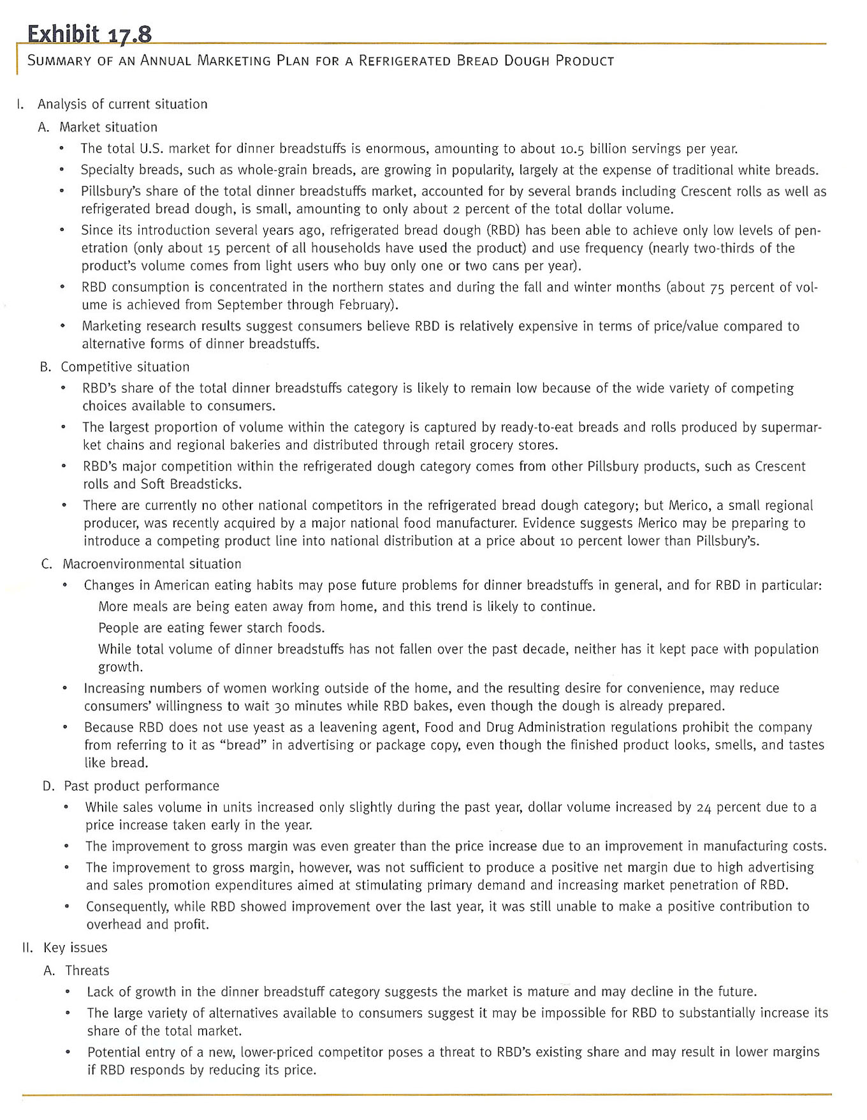

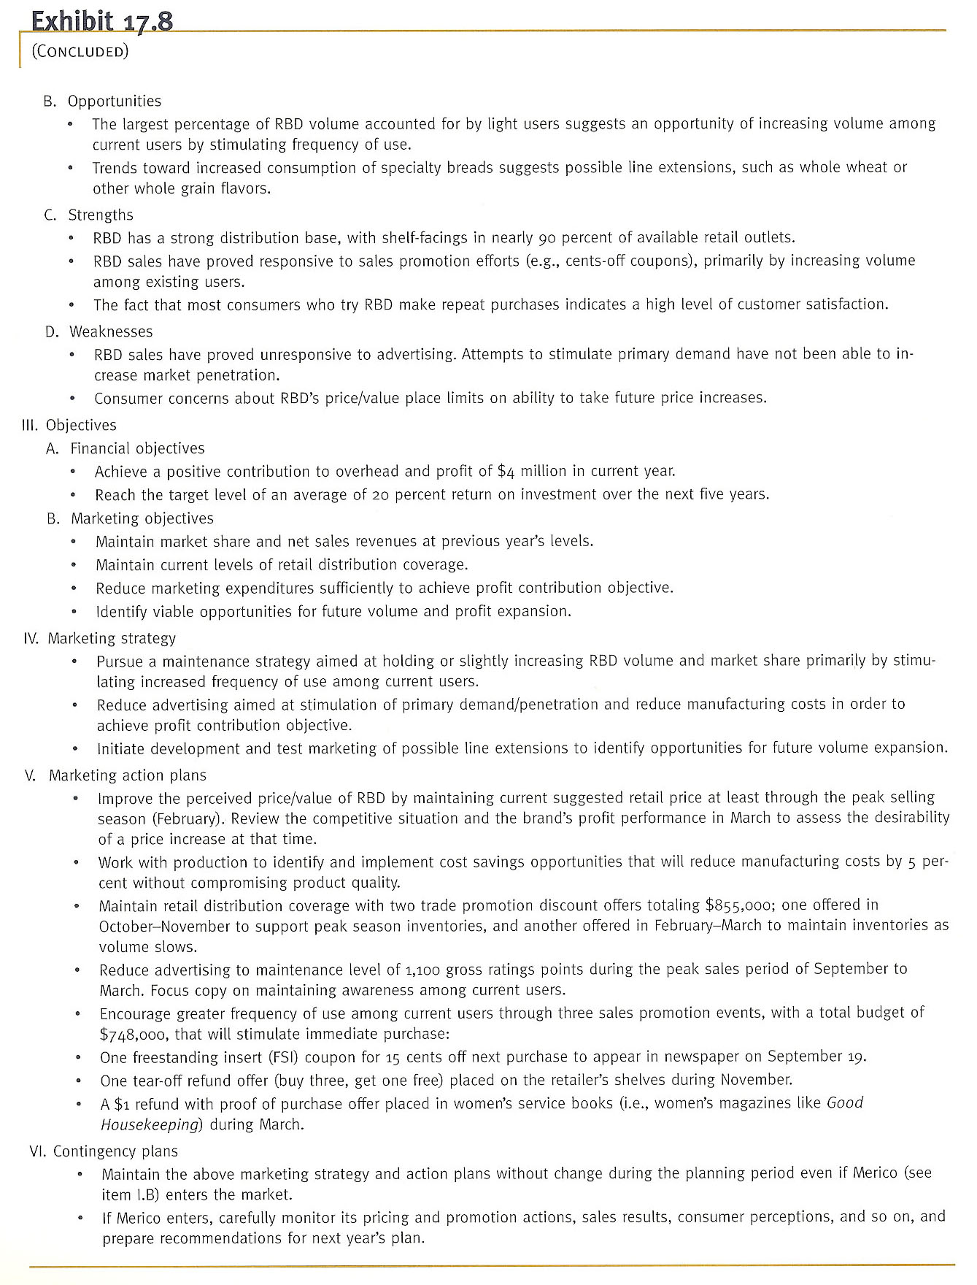

Reference 22: page 84: Goal Setting and Strategies

Your mission statement sets the broadest direction for your business. SWOT and competitive analyses help you refine your change that direction, but the goals that you set must stem from your mission statement. Obviously, goals are needed before you can build a set of strategies. As the cliché goes, "if you don't put up a target, you won't get anything." Goals need to be

- Written in terms of the outcomes rather than actions. A good goal states where you want to be, not how you want to get there. For example, a goal should focus on increasing sales rather than your intention to send one of your brochures to every address in town.
- Measurable. In order to tell whether you have accomplished the goal, you must be able to measure the outcome.
- Challenging, yet attainable. Goals that are too easy to accomplish are not motivating. Goals that are not likely to be accomplished are self-defeating and decrease motivation.
- Communicated to everyone in the company. A team effort is difficult to produce if some of your players don't know the goals.

- Written with a timeframe for achievement. Performance and motivation increase when people have goals accompanied by a timeframe as compared with open-ended goals.

Writing usable goals isn't easy at first. If you state that your goal is to be "successful," is that a good goal? It sounds positive; it sounds nice. But is it measurable? No. How can you tell whether you have achieved the goals such as this? You can't because there is no defined outcome. There is also no time frame. Do you intend to be successful this year? By the time you are 90? Goals need to characteristics listed previously to beat useful.

Although you will have only one mission statement, you will have several business level goals that apply to your entire organization. Each functional area of your business (for example, marketing, finance, human resources, and production) will have its own set of specific goals that relate directly to achieving your business level goals (see figure 3.7). Even if you are the only person performing marketing, finance, human resource management, and production duties, these areas of your small business must still be addressed individually.

- Your mission statement describes who you are, what your business is and why it exists.
- A business level goal describes what you want your overall business to accomplish to achieve your company mission.
- A function level goal describes the performance desired of specific departments (or functional areas, such as marketing, production, and so on) to achieve your business level goals.
- A strategy is a plan of action that details how you will attain your function level goals.

In the final stage of goal setting, specific strategies are developed to accomplish your goals. For example, a marketing strategy might be to hire Jerry Seinfeld to be the spokesperson for your new standup comedy computer program. This strategy should help you attain your function level marketing goal of capturing 20% market share of the total comedy software market. Your marketing goal should help you attain your business level goal of increasing third-quarter profits by 8%, which in turn ensures that you accomplish your company mission of satisfying the entertainment needs of law and the computer operators and thereby earn a profit.

Function level goals and strategies must coordinate with one another and with business level goals for the business to run smoothly. For example, the marketing department may develop a strategy of advertising on the Internet that will bring in orders from all over the globe. This result is great as long as the production department can increase capacity, the human resource department can hire and train enough new employees, and all other areas of the business are prepared. Each functional area must see itself as an integral part of the entire business and act accordingly.

